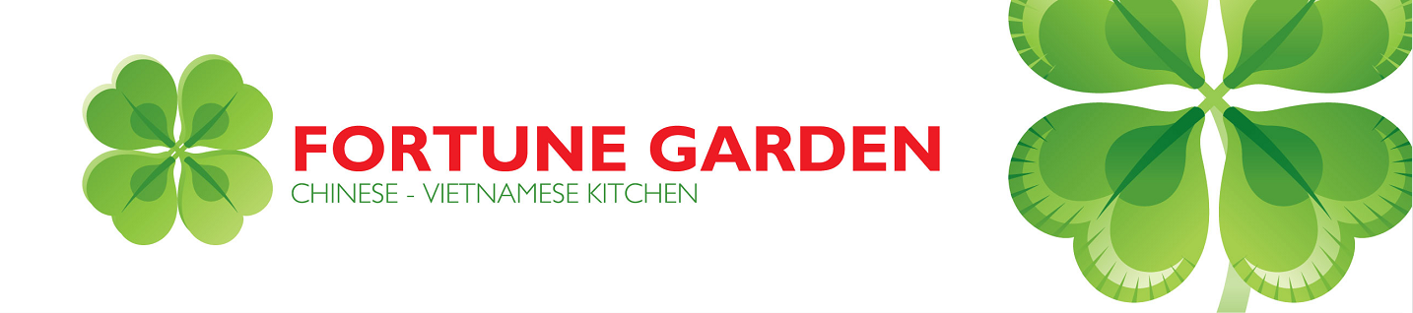
Four-leaf Clover
Author: Ella Higginson
I know a place where the sun is like gold
And the cherries bloom forth in the snow;
And down underneath is the loveliest place,
Where the four-leaf clovers grow.
One leaf is for FAITH,
And one is for HOPE,
And one is for LOVE you know;
And God put another in for LUCK.
If you search you will find where they grow.
But you must have FAITH,
And you must have HOPE,
You must LOVE and be strong and so...
If you work and you wait,
You will find the place
Where the FOUR-LEAF CLOVERS grow!

Fortune Garden
201 University Boulevard, suite 730
Round Rock, TX, 78664

